**FPT ACADEMY INTERNATIONAL**



**FPT – APTECH COMPUTER EDUCATION**

PRIME FITNESS

|  |  |  |  |
| --- | --- | --- | --- |
| **Center Name:** | FPT – Aptech – HCM2 | | |
|  | Address:590 Cach Mang Thang Tam,  District 3, Ho Chi Minh City | | |
| **Instructor:** | Ms. Le Mong Thuy | | |
|  |  | | |
| **Class:** | T1.2002.E1 | | |
| **Group:** | 02 | | |
| **Group members** | **Name**  Nguyen Viet Minh Chi | | **Student ID**  Student1251715 | |
|  | Nguyen Minh Thinh | | Student1261140 | |
|  | Nguyen Trung Thanh | | Student1248884 | |
|  |  | |  | |
| **Project Duration** | Start date | 15th June 2020 | | |
|  | End date | 17th July 2020 | | |

**This is to certify that**

#### **Mr./ Ms.:**

Nguyen Viet Minh Chi

Nguyen Minh Thinh

Nguyen Trung Thanh

**has successfully designed & developed**

eProject: Prime Fitness website

**Submitted by:**

Nguyen Viet Minh Chi

**Date of issue:** June 15th 2020

**Authorized Signature:**

TABLE OF CONTENTS

ACKNOWLEDGE 4

SYNOPSIS 4

PROBLEM DEFINITION 4

CUSTOMER'S REQUIREMENTS SPECIFICATIONS (CRS) 5

SCOPE OF THE WORK (IN BRIEF) 7

ARCHITECTURE AND DESIGN OF THE SYSTEM 8

DIAGRAM OF THE WEBSITE 9

TASK SHEET REVIEW 1 10

SITE MAP 11

MOCK OF THE WEBSITE 12

TASK SHEET REVIEW 2 24

WEBSITE DESCRIPTION 25

JAVASCRIPT DESCRIPTION 42

TASK SHEET REVIEW 3 47

# ACKNOWLEDGE

# To have a successful project, it is the continuous effort of many people. The most important person is Ms. Le Mong Thuy – our teacher. With many years’ experience of teaching, along with enthusiasm as well as rigorous in guiding the project, she is the person who helped us complete the subject to catch the schedule can achieve our goal. Besides, this is the efforts and curiosity of the members in our group. We have focused on starting the project very early, promoting teamwork by sharing experiences and knowledge with each other throughout the project. The last but not least, we would like to say thank you to our family for always supporting us, creating the best conditions for us to focus on the project, and putting faith in the dreams we pursue.

# SYNOPSIS

# The PRIME FITNESS website is a health club website. This is a place that houses exercise equipment for the purpose of physical exercise. It is known as a “company providing people, access to controlled environmental condition space and services focused on physical fitness and health in exchange of a fee”.

# Health club have a main workout area, which use gears, services and other mechanism to guide user’s exercise. Health club also offers many services like membership prices, social activities, etc.

# This Website about health will help people understand more about fitness club by showing all the type of services and physical exercises that make customer more choice to choose and become healthier to live a happy life.

# PROBLEM DEFINITION

The Web site is to be created based on the following requirements.

1. The Home page should be design with the appropriate template and navigation link.
2. Designing and navigation both must be made user friendly.
3. Links can be:

- Cycling.

- Swimming.

- Sports & Fitness.

- Group Exercise.

- Membership.

- Salon & Spa.

- Gallery.

- List of equipment with its description.

1. About us. There should be a “Contact Us” page which will have the Address of the Company which should be displayed using Geolocation API (e.g. Google Maps) and the email address which when clicked will invoke the local mail client from where they can send an email.
2. FAQs.
3. Enquiry Form.
4. Site Map.

# CUSTOMER'S REQUIREMENTS SPECIFICATIONS (CRS)

## **CLIENT:** Prime Fitness

## ****BUSINESS/PROJECT OBJECTIVE:****

Prime Fitness is fitness club established in the year 1982. The fitness club has equipped with all basic fitness equipment and also included the newly introduced. The Prime fitness club is the flagship brand for Prime Fitness Club Ltd, a UN based health and fitness services provider and a pioneer in the “Integrated Health Club Management Solution’s business. Prime Fitness Club Ltd focuses on staying fit is most important to meet the challenging requirements.

We are supposed to create a website for yours with the below mentioned requirement specifications.

The website is to be developed for the Windows Platform using HTML5, JavaScript and Geolocation. The site should work well in all leading browsers including Chrome, IE, Firefox etc.

**Input to the system:**

* Register a trial class on website.
* Register member on website.
* Leave comment to the fitness club.
* Send mail to the fitness club.

**Output from the system:**

* Display result of the frequently asked questions from the FAQs form.
* Display the local mail client when user click to the mail address in Contact Us page.
* Display the images and timetable class.

**Process:**

* Show the answer of frequently asked questions.
* Show and short the picture in Gallery page.
* Show and sort timetable for each class in Services page.

**Expected delivery date:** 17 July 2020

**List of deliverables:**

* Document Word.
* User Guild.
* Source code.

## HARDWARE/ SOFTWARE REQUIREMENTS:

**For webmaster**

##### **Hardware**

* Intel Pentium 4 processor or higher
* 1 Gigabytes of RAM or higher

##### **Software**

* Windows 7 OS or higher
* Adobe Dreamweaver
* Web browsers such as IE, Chrome or Firefox are supporting HTML5, CSS3 and JavaScript.

#### **For web users**

##### **Hardware**

* Intel Pentium 4 processor or higher
* 512 Megabytes of RAM or higher

##### **Software**

* Windows XP OS or higher
* Web browsers such as IE, Chrome or Firefox are supporting HTML5, CSS3 and JavaScript.

# SCOPE OF THE WORK (IN BRIEF)

After a long and detailed discussion, our group has decided to create a website contain the following webpages:

* Homepage: introduce about Prime Fitness club. Display information about services, classes, trainer, success stories, membership benefits and register form of the fitness club.
* Services: display a list of services, including courses on Cycling, Swimming, Sports & Fitness, Group Exercise and Salon & Spa services for customers to look for their wanted choice.
* Equipment: display the equipment and its description which used in the Prime fitness club.
* Gallery: display the images of services in Prime Fitness club like Cycling, Swimming, Sports & Fitness, Group Exercise, Salon & Spa and other.
* FAQs: display the frequently asked question related to the fitness club and show the answer for customers.
* Enquiry form: allow users register member on website.
* Membership: display the membership benefits for new members and display class schedule of unlimited class.
* Contact us: display the address, map, phone, mail and allow customers open local mail by clicking email address of Prime Fitness to request any information they want to the Prime Fitness club.

# ARCHITECTURE AND DESIGN OF THE SYSTEM

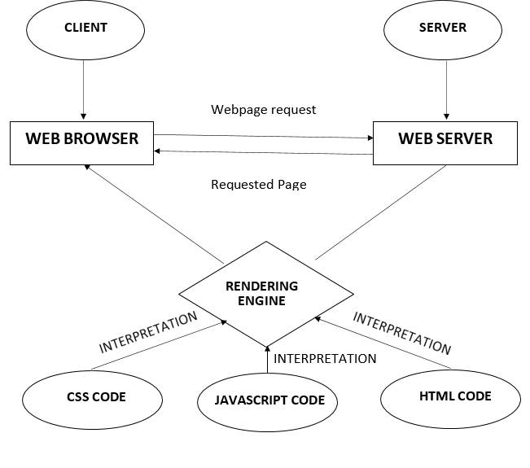

# DIAGRAM OF THE WEBSITE

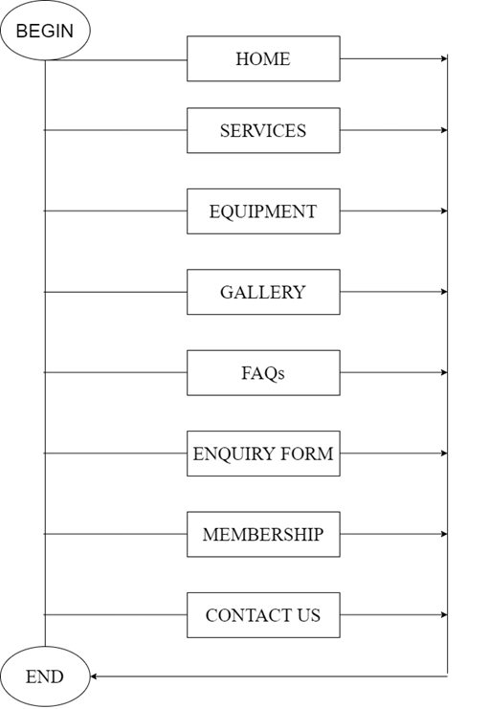

# TASK SHEET REVIEW 1

|  |  |  |  |  |  |  |  |
| --- | --- | --- | --- | --- | --- | --- | --- |
| **Project Ref. No.: eP/Advertisement Portal Management System/01** | | **Project Name** | **Activity Plan Prepared By** | **Date of Preparation of Activity Plan:** | | | |
| **Sr./No.** | **Task** | **Actual Start Date** | **Actual Days** | **Team member name** | **Status** |
| 1 | Problem statement | Prime Fitness website | Chi | 15-Jun-20 | 1 | Chi | Completed |
| 2 | Analysis Prime Fitness website’s requirement | 15-Jun-20 | 1 | Thinh | Completed |
| 3 | The scope of the work (in brief) | 15-Jun-20 | 1 | Thinh | Completed |
| 4 | Architecture and design of the system | 16-Jun-20 | 2 | Thanh | Completed |
| 5 | Diagram of the website | 16-Jun-20 | 2 | Thanh | Completed |
| 6 | Task Sheet | 16-Jun-20 | 2 | Chi | Completed |

|  |  |
| --- | --- |
| **Date: 17 Jun 2020** | |
| Signature of Instructor:  **Ms. Le Mong Thuy** | Signature of Team Leader:  **Nguyen Viet Minh Chi** |

# SITE MAP

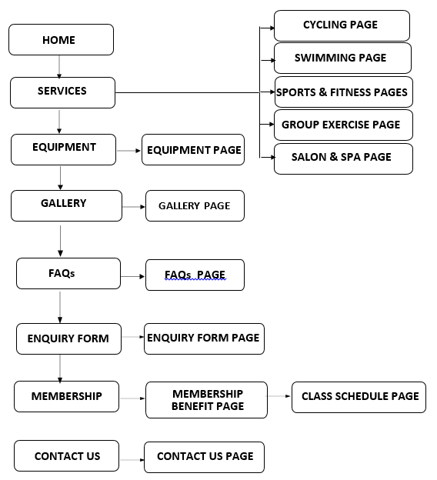

# MOCK OF THE WEBSITE

1. HOME PAGE

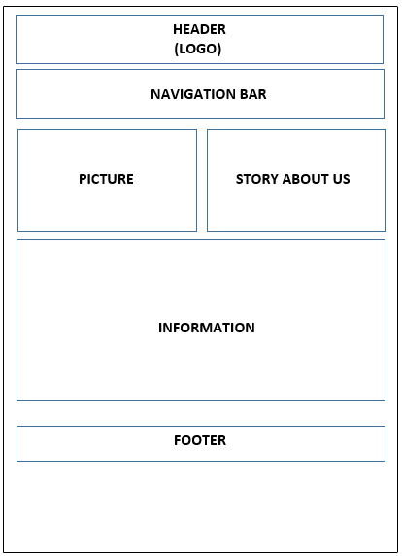

1. Services
   1. Cycling

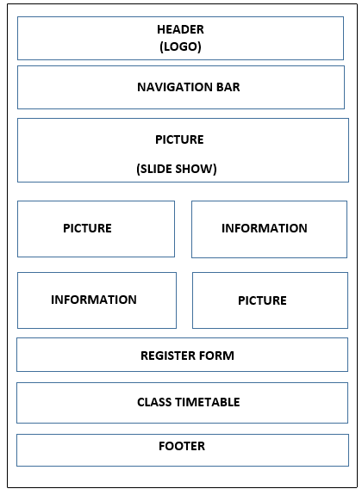

* 1. Swimming



* 1. Sports & Fitness



* 1. Group Exercise



* 1. Salon & Spa

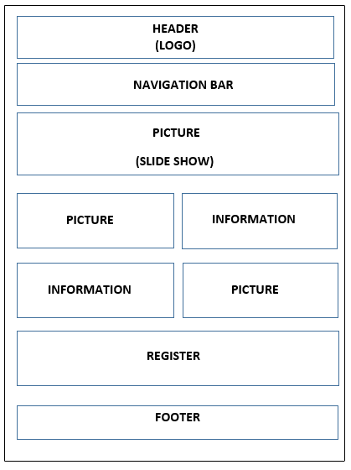

1. Equipment

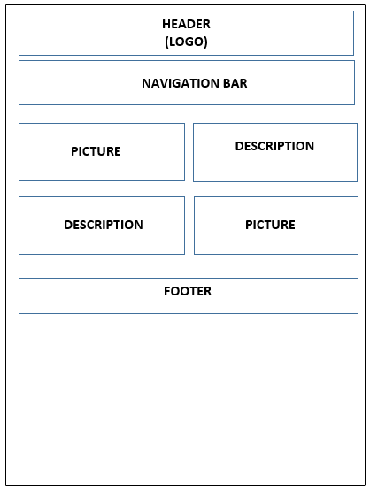

1. Gallery

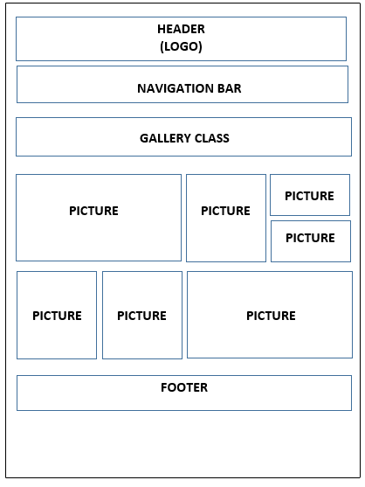

1. FAQs

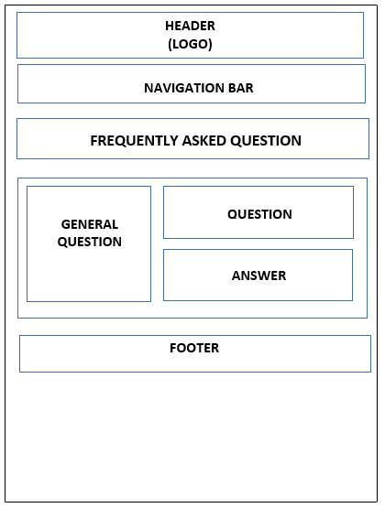

1. Enquiry Form

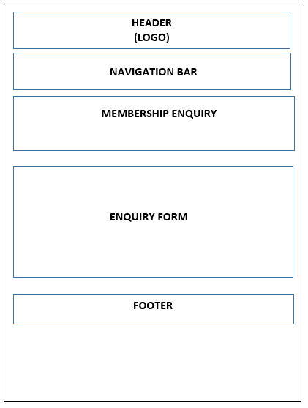

1. Membership

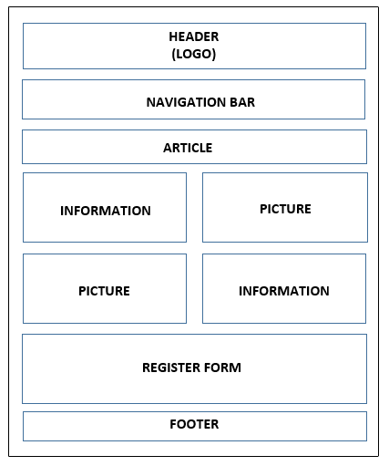

1. Contact Us

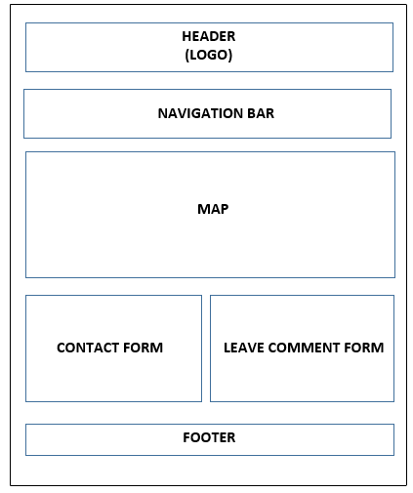

# TASK SHEET REVIEW 2

|  |  |  |  |  |  |  |  |
| --- | --- | --- | --- | --- | --- | --- | --- |
| **Project Ref. No.: eP/Advertisement Portal Management System/01** | | **Project Name** | **Activity Plan Prepared By** | **Date of Preparation of Activity Plan:** | | | |
| **Sr./No.** | **Task** | **Actual Start Date** | **Actual Days** | **Team member name** | **Status** |
| 1 | Site map | Prime Fitness website | Chi | 17-Jun-20 | 1 | Thanh | Completed |
| 2 | Mock of website | 18-Jun-20 | 2 | Thinh | Completed |
| 3 | Task Sheet | 18-Jun-20 | 2 | Chi | Completed |

|  |  |
| --- | --- |
| **Date: 18 Jun 2020** | |
| Signature of Instructor:  **Ms. Le Mong Thuy** | Signature of Team Leader:  **Nguyen Viet Minh Chi** |

# WEBSITE DESCRIPTION

1. Home page
2. Description

This webpage displays following information: Prime Fitness introduction, story about Prime Fitness and video, range of Prime Fitness services, unlimited classes, information about web creator, success story of member in Prime Fitness club, membership plans information, register form.

1. 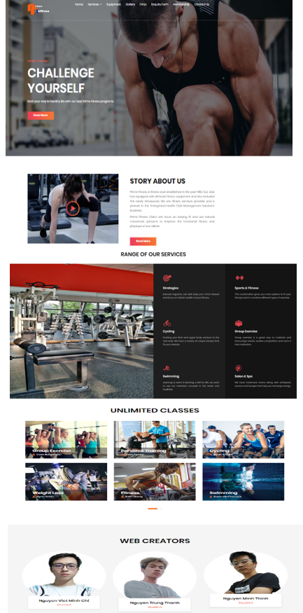Screenshot

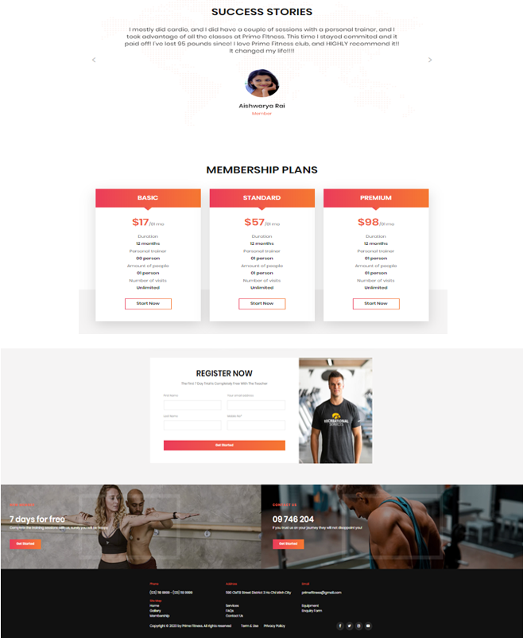

1. Services
   1. Cycling
2. Description

This webpage displays general information about the types of indoor bicycles and the benefits that cycling brings to customer. Users can review information from their favorite classes and sort class timetable on website by clicking on All gallery, Cycling, Swimming, Sports & Fitness, Group Exercise. Moreover, users can conduct a free 7-day trial on the registration form.

1. 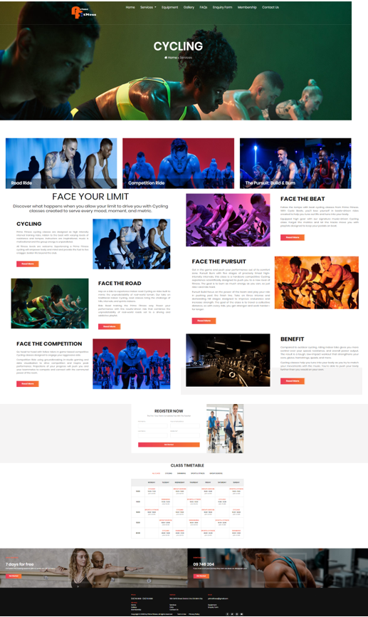Screenshot
2. Example of sort class timetable

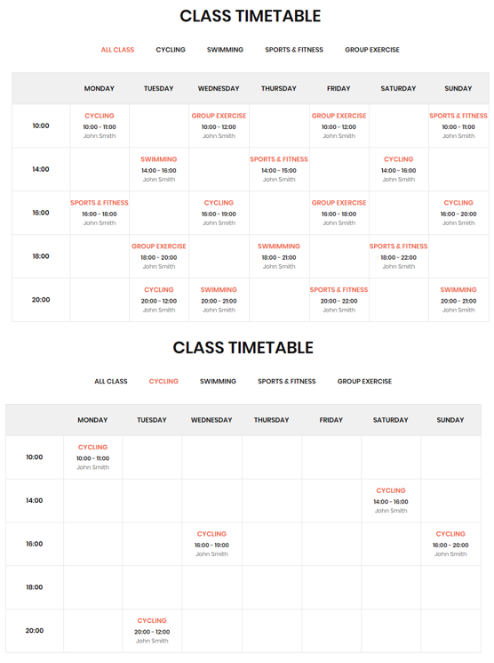

* 1. Swimming

1. Description

This webpage displays information and history of swimming. Users will get useful information and benefits of learning to swim. Users can sort the time of swimming classes in the class timetable and register a free 7-days trial on registration form.

1. 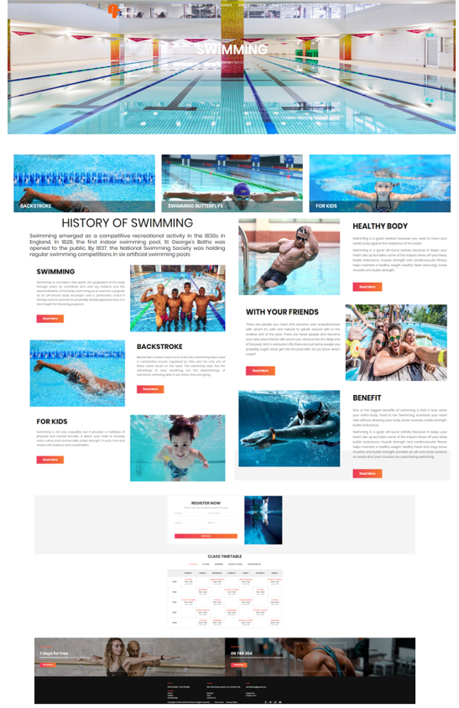Screenshot
   1. Sports & Fitness
2. Description

This webpage displays information about the combination of sports and fitness. Users will get useful information and benefits when participating in these courses. Users can sort the time of sports & fitness classes in the class timetable and register a free 7-days trial on registration form.

1. 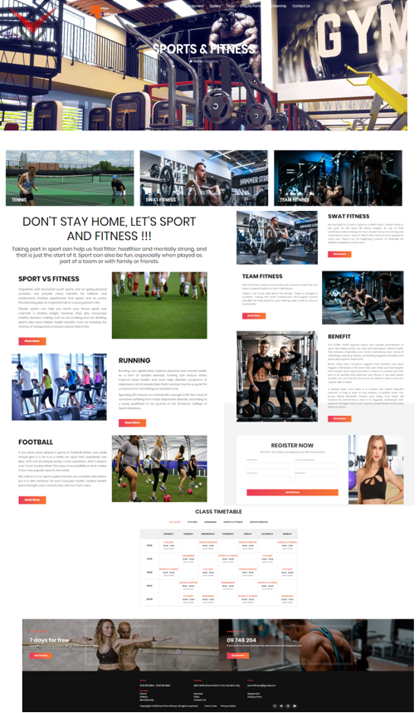Screenshot
   1. Group Exercise
2. Description

This webpage displays information about the types of group exercise. Users will have more information and activities related to group exercise. Users can consider the timetables of these classes and sign up for a free 7-day trial on the registration form.

1. 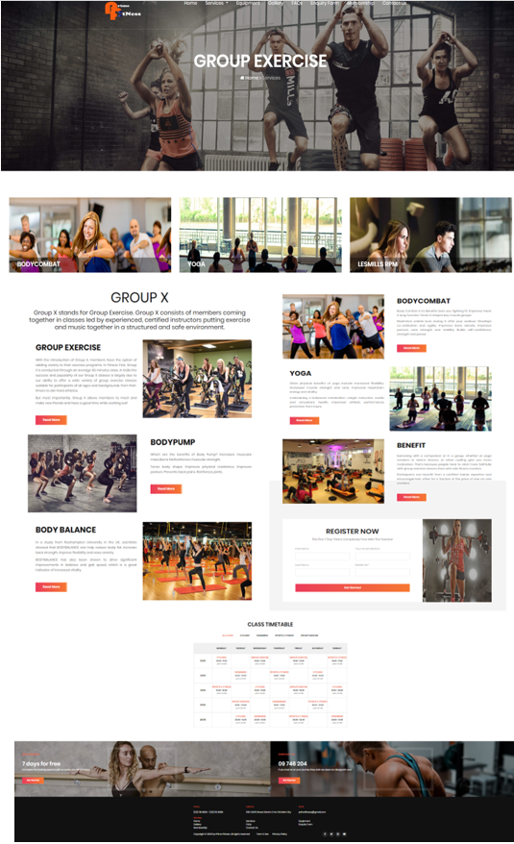Screenshot
   1. Salon & Spa
2. Description

This webpage displays information about skin care and hair-cutting services to customers. Users will have more information about the type of products and beauty steps in salon and spa. Users can register to use the service on the registration form.

1. 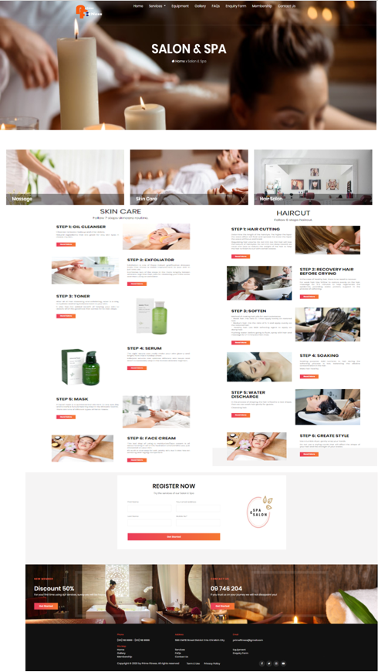Screenshot
2. Equipment
3. Description

This webpage displays information about equipment and amenities at Prime Fitness Club. Users will have more detailed information about the type of equipment and training space.

1. 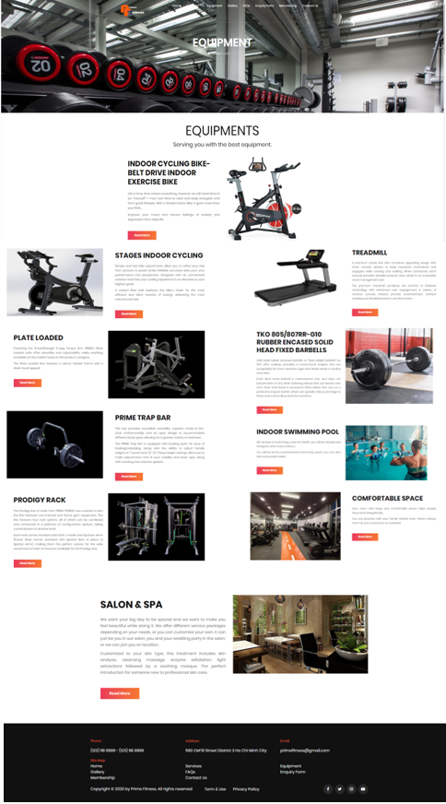Screenshot
2. Gallery
3. Description

This webpage displays pictures of members practicing at Prime Fitness Club. Users can filter images for each topic by clicking on All gallery, Cycling, Swimming, Sports & Fitness, Group Exercise or Other.

1. Screenshot

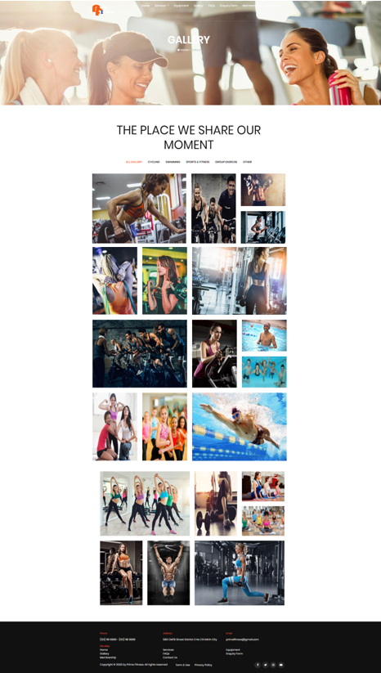

1. 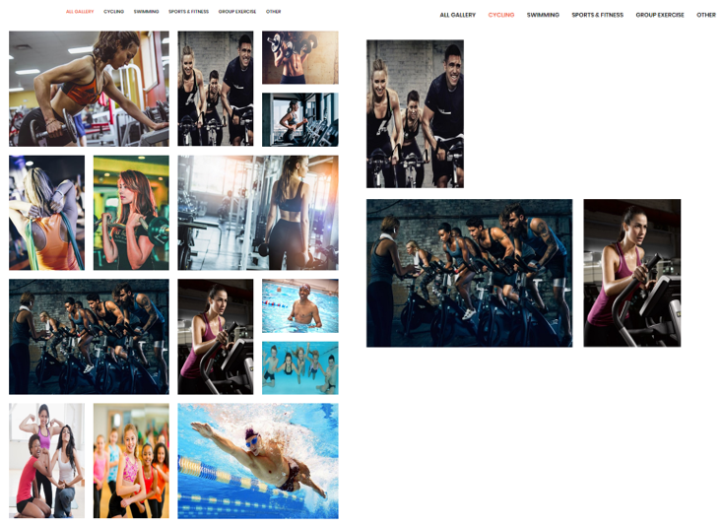Example of sort picture in gallery

1. FAQs
2. Description

This webpage displays frequently asked questions. Users can find questions by each general topic. If the users want to see the answer of a specific question, they will click on the question and the answer will be displayed.

1. 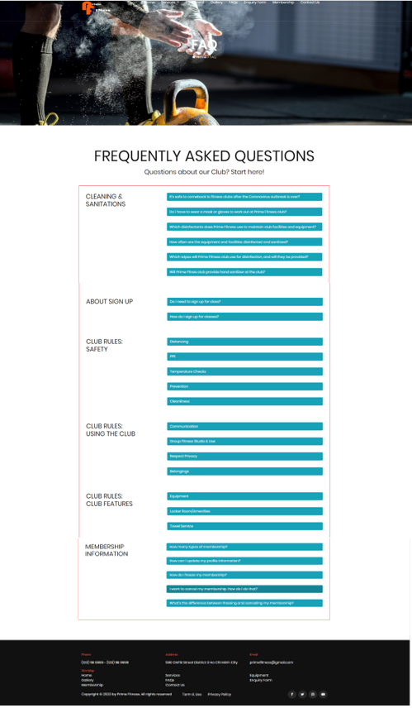Screenshot
2. Example of answer frequently asked question

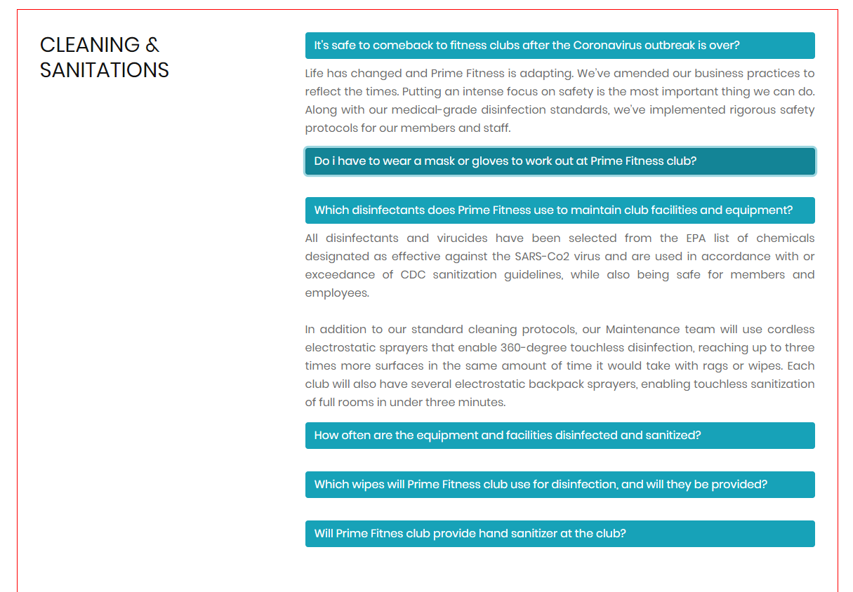

1. Enquiry Form
2. Description

This webpage allows users register to become members of the club. Allow users to fill in personal information, register for classes, select membership types and send requests to the club.

1. Screenshot

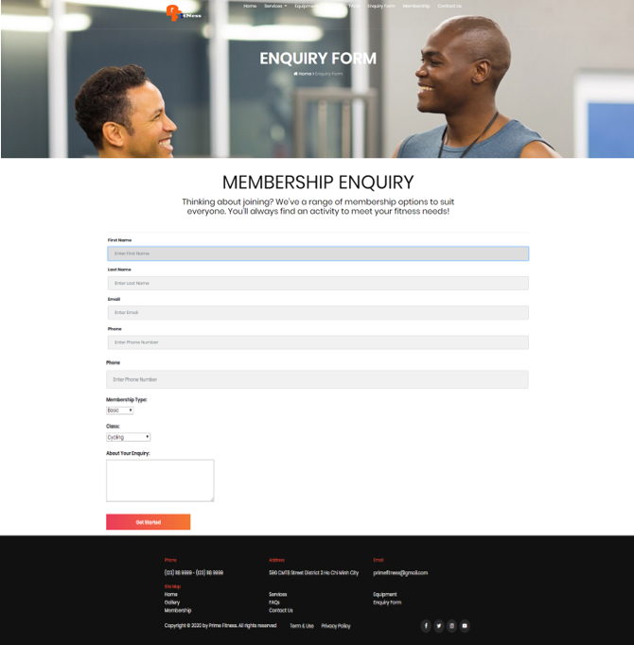

1. Membership
2. Description

This webpage displays the benefits of being a member of the club. Allow users to fill in personal information to book an appointment before coming to the club and find the class timetable in unlimited class when users click “class schedule”.

1. Screenshot

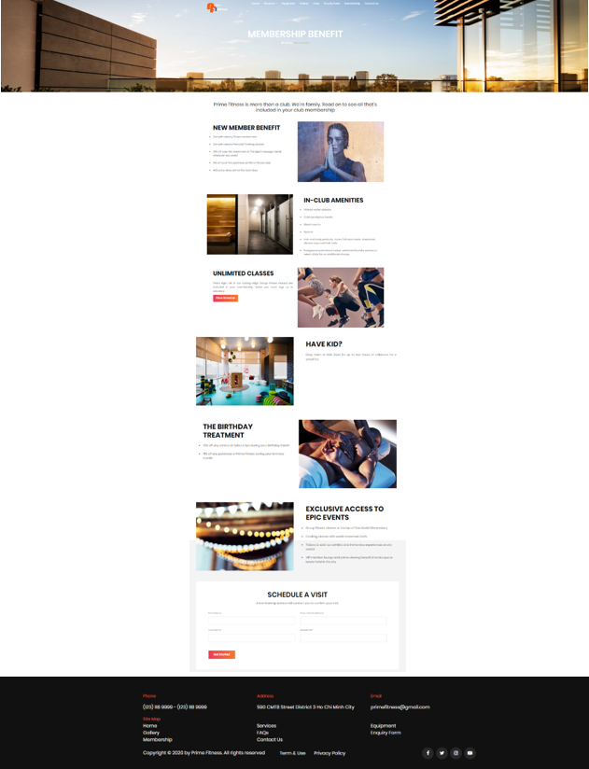

1. Contact Us
2. Description

This webpage allows users to request information they inquire to Prime Fitness club, open local mail by clicking email address and displays the geo location of the club.

1. Screenshot

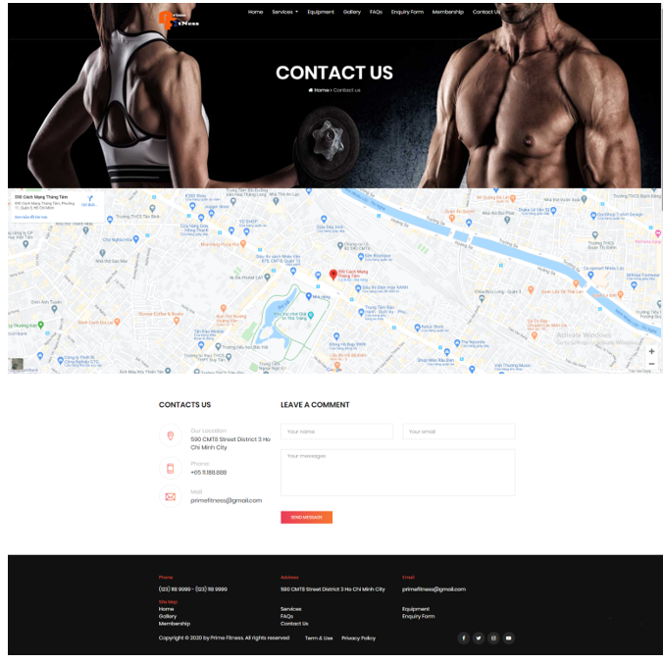

1. Example of open local mail by clicking email address

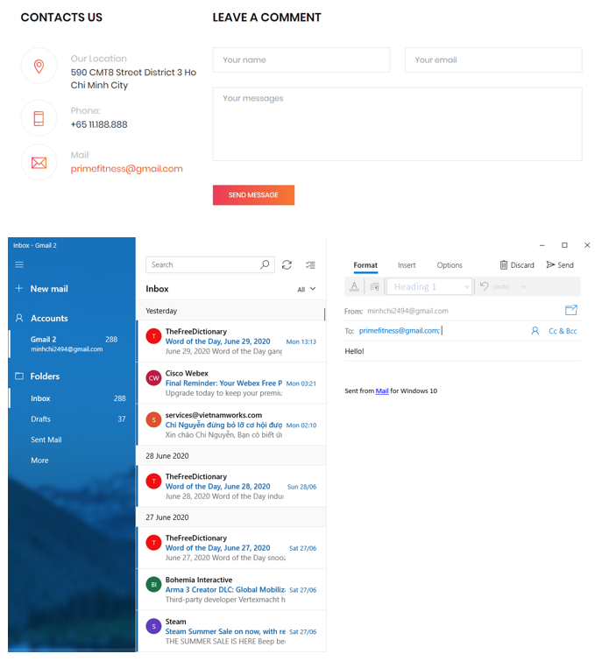

# JAVASCRIPT DESCRIPTION

This chapter will provide information about JavaScript function integrated in the website.

1. Class timetable filter function
2. Description

This script is used for filter detailed class information in Service pages. It is implemented with the support of the Jquery library.

1. Screenshot

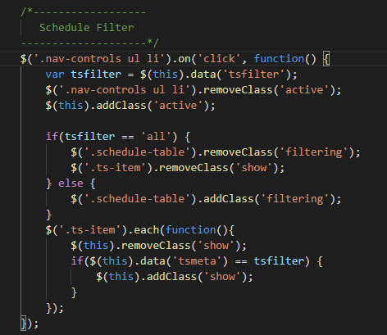

1. Toggle answer function
2. Description

This script is using for toggle answer of frequently asked question in FAQs page. It is implemented with the support of the Jquery library.

1. 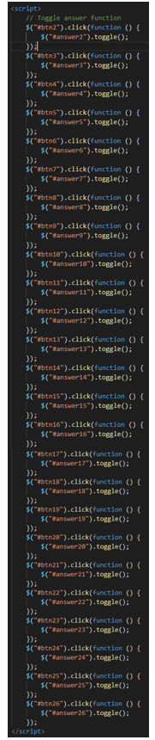Screenshot
2. Video popup function
3. Description

This script is used for pop up video about Prime Fitness club in Home page. It is implemented with the support of the Jquery library and magnificPopup library.

1. Screenshot

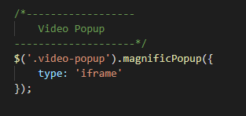

1. Gallery filter function
2. Description

This script is used for filter images by classes in Gallery page. It is implemented with the support of the Jquery library.

1. Screenshot

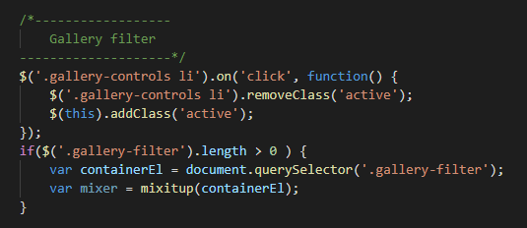

1. Images slider function
2. Description

This script is used for images slider. It is implemented with the support of the Jquery library and OwlCarousel library.

1. Screenshot

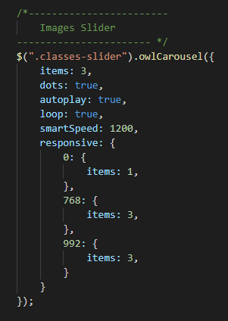

1. Success stories slider
2. Description

This script is used for text and images slider. It is implemented with the support of the Jquery library and OwlCarousel library.

1. Screenshot

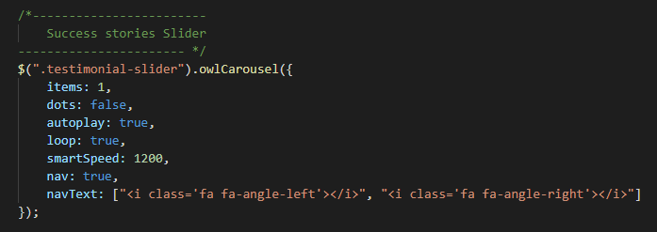

# TASK SHEET REVIEW 3

|  |  |  |  |  |  |  |  |
| --- | --- | --- | --- | --- | --- | --- | --- |
| **Project Ref. No.: eP/Advertisement Portal Management System/01** | | **Project Name** | **Activity Plan Prepared By** | **Date of Preparation of Activity Plan:** | | | |
| **Sr./No.** | **Task** | **Actual Start Date** | **Actual Days** | **Team member name** | **Status** |
| 1 | Home | Prime Fitness website | Chi | 20-Jun-20 | 2 | Chi | Completed |
| 2 | Cycling | 22-Jun-20 | 2 | Chi | Completed |
| 3 | Swimming | 24-Jun-20 | 3 | Thinh | Completed |
| 4 | Sports & Fitness | 27-Jun-20 | 2 | Thinh | Completed |
| 5 | Group Exercise | 29-Jun-20 | 2 | Thinh | Completed |
| 6 | Salon & Spa | 01-July-20 | 2 | Thanh | Completed |
| 7 | Equipment | 03-July-20 | 3 | Thanh | Completed |
| 8 | Gallery | 06-July-20 | 3 | Chi | Completed |
| 9 | FAQs | 09-July-20 | 1 | Chi | Completed |
| 10 | Enquiry Form | 10-July-20 | 2 | Thanh | Completed |
| 11 | Membership | 12-July-20 | 2 | Thinh | Completed |
| 12 | Contact Us | 14-July-20 | 2 | Thanh | Completed |

|  |  |
| --- | --- |
| **Date: 16 July 2020** | |
| Signature of Instructor:  **Ms. Le Mong Thuy** | Signature of Team Leader:  **Nguyen Viet Minh Chi** |